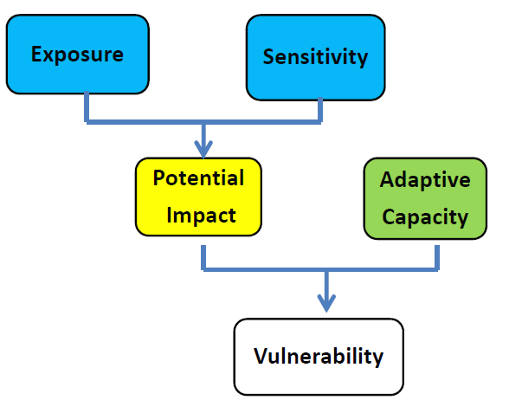
Terminology and Definitions:
- Vulnerability: A function of the sensitivity of a particular resource to climate changes, its exposure to those changes, and its capacity to adapt to those changes (IPCC 2007)
- Sensitivity: Sensitivity to climate and climate-driven factors involves stressors that currently shape the species, habitat or ecosystem services. Sensitivity is how much the target is affected by a given amount of change
  - Species Sensitivity to climate and climate-driven factors may be direct (e.g., physiological, phenological) or indirect (e.g., ecological relationships).
    - Physiological sensitivity refers to a species’ physiological ability to tolerate changes that are higher or lower than the range that they currently experience. Species that are able to tolerate a wide range of climatic factors may be considered less sensitive.
    - Phenological sensitivity refers to a species’ ability to phenologically track climate (e.g., temperature). Species that cannot phenologically track environmental changes may be considered more sensitive.
    - Species’ ecological relationships may also be affected by climate or climate-driven factors. Ecological relationships could include: predator/prey, foraging, competition, habitat, pollination, dispersal, symbiont/mutualist/parasite, and others. Ecological relationships significantly affected by small changes in climate and climate-driven factors likely have higher sensitivity.
- Habitat Sensitivity to climate and climate-driven factors:
- Whether the habitat exists in a relatively narrow climatic zone(s), and thus is more sensitive; or it exists in a relatively broad climatic zone(s) and thus is less sensitive;
- Whether the habitat experiences large changes in composition or structure due to small changes in climate or climate-driven factors, and thus is more sensitive; or the habitat experiences small changes even with larger changes in climate or climate-driven factors, and thus is less sensitive.
- Sensitivity of an Ecosystem Service may largely be determined by the sensitivities of those components (e.g., species, habitat, hydrology, etc.) that provide or support the service. For example, the sensitivity of “marine fisheries” as an ecosystem service is significantly determined by the sensitivity of the target species climate and climate-driven factors (e.g., pH or temperature). Similarly, the sensitivity of recreation as an ecosystem service is dependent on the sensitivity of target species (e.g., birds for bird-watching), habitat (e.g., beaches for sunbathing), or process (e.g., changes in hydrology affecting the ability to whitewater raft).

- Exposure: involves future climate changes that could affect the species, habitat, or ecosystem service. Exposure is how much change occurs, including changes outside the project area that affect the target (e.g. loss of glaciers loss of water supply).
- Adaptive Capacity is the ability of an individual, community, or ecosystem to adapt to change; this reflects intrinsic traits (behavioral flexibility that allows individuals to respond to new situations) and extrinsic factors (e.g. degree of habitat fragmentation).

Adaptation Terminology:
Adaptation goal: General characterization of what an adaptation activity is attempting to achieve.
Adaptation strategy: General statements of how to reduce climate vulnerabilities or increase resilience within a given goal.
Adaptation action: Specific activity that facilitate progress towards achieving an adaptation strategy.

Figure 1. Visual representation of relationship between adaptation goals, strategies, and actions.
Most adaptation activities fall into the following five categories:
- Enhance Resistance. Implementation of these strategies can help to prevent the effects of climate change from reaching or affecting a resource. Common types of resistance actions are activities designed to reduce non-climate stressors.
- Promote Resilience. These strategies can help a resource weather the impacts of climate change by avoiding the effects of or recovering from changes.
- Facilitate Transition (or Response). Transition or response strategies intentionally accommodate change and enable resources to adaptively respond to changing and new conditions.
- Increase Knowledge. These strategies are aimed at gathering more information about climate changes, impacts, and/or the effectiveness of management actions in addressing the challenges of climate change.
- Enhance Coordination. Coordination strategies help organize adaptation efforts across various groups (e.g., sectors, governments, project teams). They may help align budgets and priorities for a program of work across lands, or establish or expand collaborative monitoring efforts or projects, among others.

